**EX NO: 01 CELCIUS TO FAHERNHEIT CONVERSION**

**DATE:**

**AIM:**

To write a python program to celcius to fehrenheit conversion.

**ALGORITHM:**

1. Open Python IDLE
2. Click File -> New file
3. Type the program
4. Save the program with .py extension
5. To execute the program click Run or press F5
6. Exit

**PROGRAM:**

print(" please enter 1 for celcius to fahrenheit and 2 for fahrenheit to celciusconvertion")

con=int(input("Enter 1 or 2 :"))

if (con == 1):

cel=int(input("Enter the tempurature in celcius :"))

f=(cel*1.8)+32

print("Temperature in Farenheit is : ",f)

else:

faren=int(input("Enter the temperature in Farenheit : "))

c=(faren - 32)/1.8

print("Temperature in celcius is :",c)

**OUTPUT:**

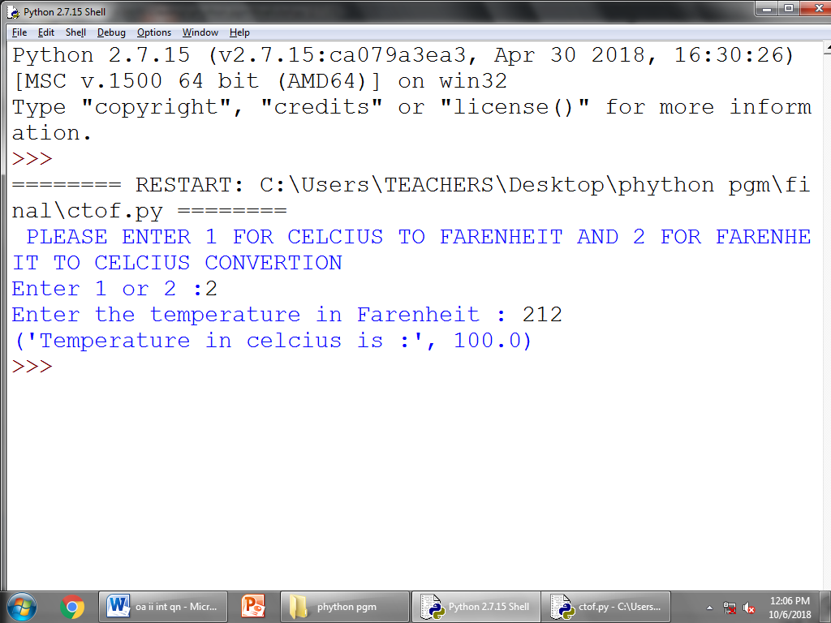

**RESULT:**

Thus the python program was successfully executed and output is verified.

**EX NO: 02 MARK GRADE USING IF-ELSE STATEMENT**

**DATE:**

**AIM:**

To write a python program was mark grade using if-else statement.

**ALGORITHM:**

1. Open Python IDLE
2. Click File -> New file
3. Type the program
4. Save the program with .py extension
5. To execute the program click Run or press F5
6. Exit

**PROGRAM:**

**# PYTHON TO FIND MARK GRADE**

mark1=int(input("Enter the mark1: "))

mark2=int(input("Enter the mark2: "))

mark3=int(input("Enter the mark3: "))

mark4=int(input("Enter the mark4: "))

mark5=int(input("Enter the mark5: "))

total=(mark1+mark2+mark3+mark4+mark5)

print "The Total mark is :"+ str(total)

percent=(mark1+mark2+mark3+mark4+mark5)/5

print("The mark percentage is:"+ str(percent)+ "%")

if(percent>=80):

print ("The GRADE is A")

elif(percent>=70 and percent<80):

print("The GRADE is B")

elif(percent>=60 and percent<70):

print("The GRADE is C")

elif(percent>=40 and percent<60):

print("The GRADE is D")

elif(percent<40):

print("The GRADE is E")

else:

print("FAIL")

**OUTPUT:**

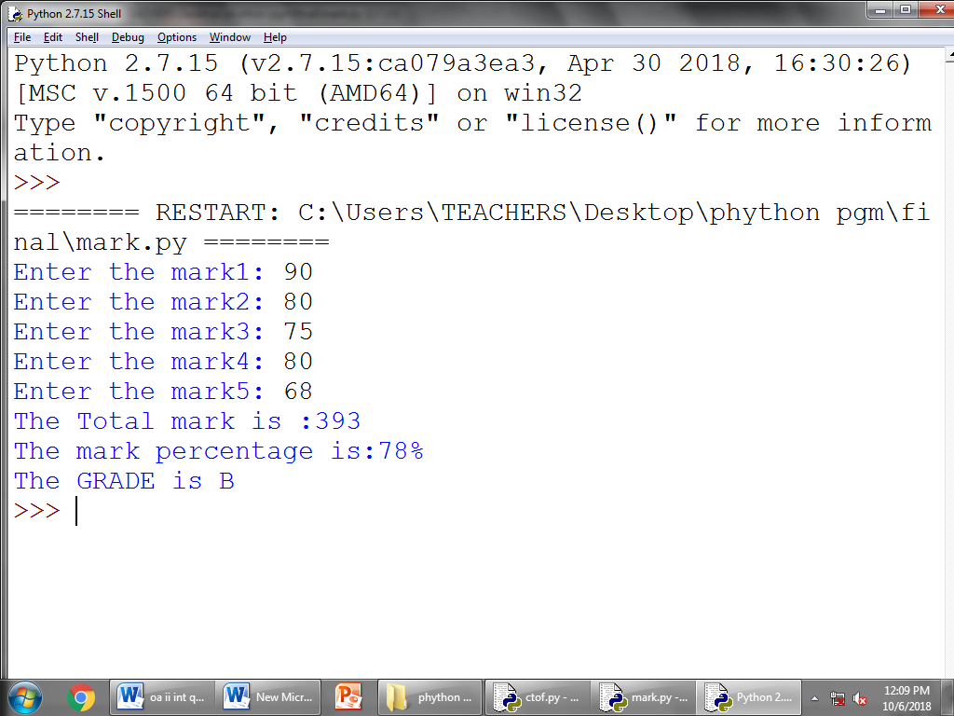

**RESULT:**

Thus the python program was successfully executed and output is verified.

**EX NO:03 GREATEST COMMON DIVISION(GCD)**

**DATE:**

**AIM:**

To calculate the number for greatest common division

**ALGORITHM:**

1. Open Python IDLE
2. Click File -> New file
3. Type the program
4. Save the program with .py extension
5. To execute the program click Run or press F5
6. Exit

**PROGRAM:**

defgcd(a,b):

if(b==0):

return a

else:

returngcd(b,a%b)

a=int(input("Enter the first number: "))

b=int(input("Enter the second number: "))

GCD=gcd(a,b)

print("GCD is : ")

print(GCD)

**OUTPUT:**

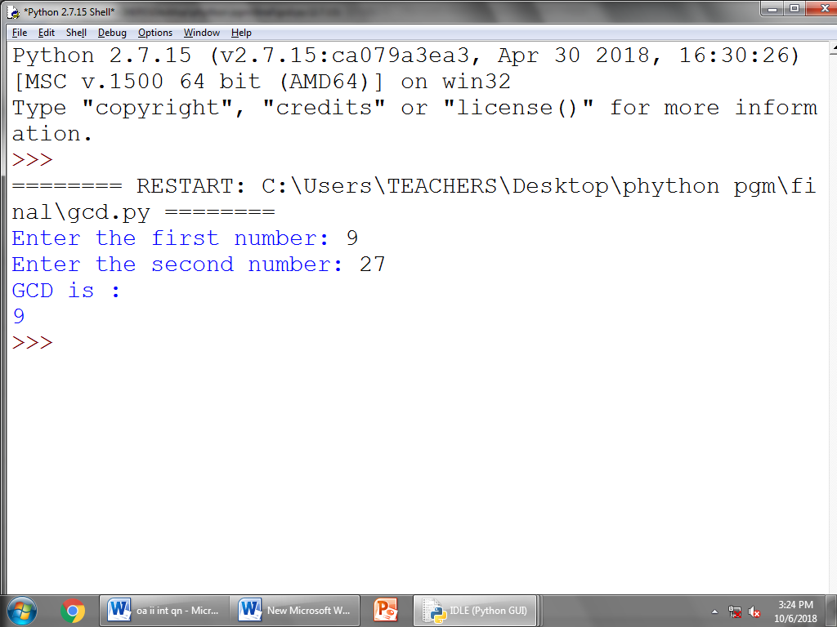

**RESULT:**

Thus the python program was successfully executed and output is verified.

**EX NO:04 FACTORIAL CALCULATION**

**DATE:**

**AIM:**

To write a python program was factorial calculation.

**ALGORITHM:**

1. Open Python IDLE
2. Click File -> New file
3. Type the program
4. Save the program with .py extension
5. To execute the program click Run or press F5
6. Exit

**PROGRAM:**

def fact(x):

if x==1:

return 1

else:

return(x*fact(x-1))

n=int(input("Enter the value : "))

print "The factorial of " , n , "is :",fact(n)

**OUTPUT:**

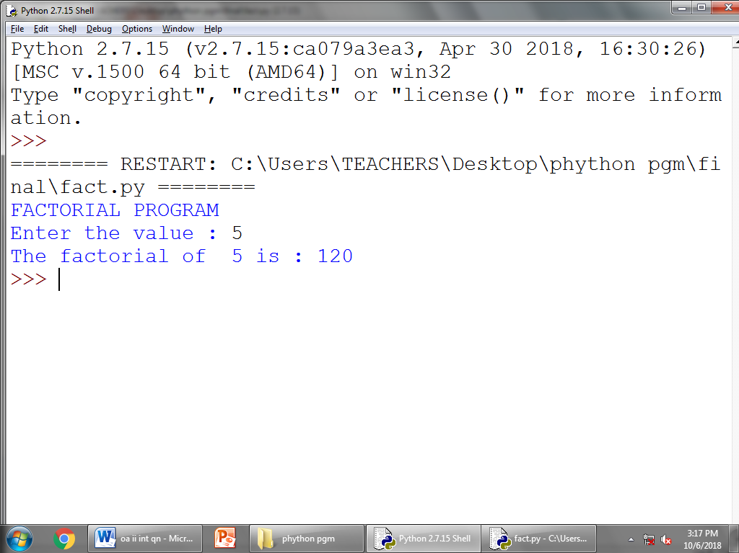

**RESULT:**

Thus the python program was successfully executed and output is verified.

**EX NO: 05 FIBONACCI SERIES**

**DATE:**

**AIM:**

To write a python program was Fibonacci series calculation.

**ALGORITHM:**

1. Open Python IDLE
2. Click File -> New file
3. Type the program
4. Save the program with .py extension
5. To execute the program click Run or press F5
6. Exit

**PROGRAM:**

print("FIBONACCI SERIES")

nterms=int(input("How many terms : "))

n1=0

n2=1

count=0

ifnterms<=0:

print ("Please enter the positive integer")

elifnterms==1:

print ("Fibonacci sequence upto ",nterms," is : " ,n1)

else:

print ("Fibonacci sequence upto ",nterms," terms is : ")

while (count <nterms):

print (n1)

nth=n1+n2

n1=n2

n2=nth

count+=1

**OUTPUT:**

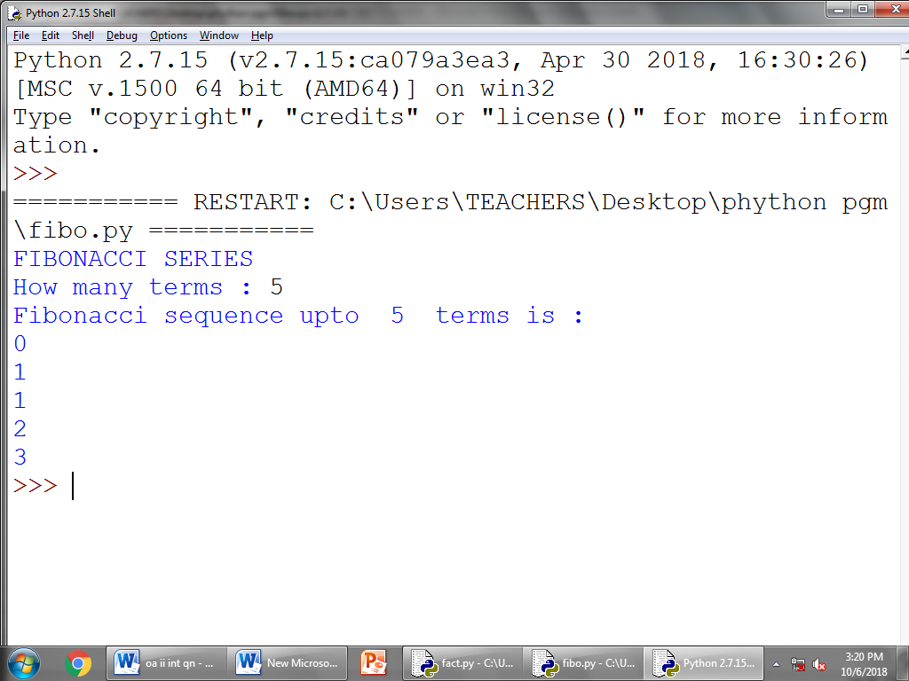

**RESULT:**

Thus the python program was successfully executed and output is verified.

**EX NO:06 MATRIX ADDITION**

**DATE:**

**AIM:**

To write a python program was matrix addition in two numbers.

**ALGORITHM:**

1. Open Python IDLE
2. Click File -> New file
3. Type the program
4. Save the program with .py extension
5. To execute the program click Run or press F5
6. Exit

**PROGRAM:**

x=[[1,1,1],[1,1,1],[1,1,1]]

y=[[1,1,1],[1,1,1],[1,1,1]]

result=[[0,0,0],[0,0,0],[0,0,0]]

for i in range(len(x[0])):

for j in range(len(y[0])):

result[i][j]+=x[i][j]+y[i][j]

for r in result:

print(r)

**OUTPUT:**

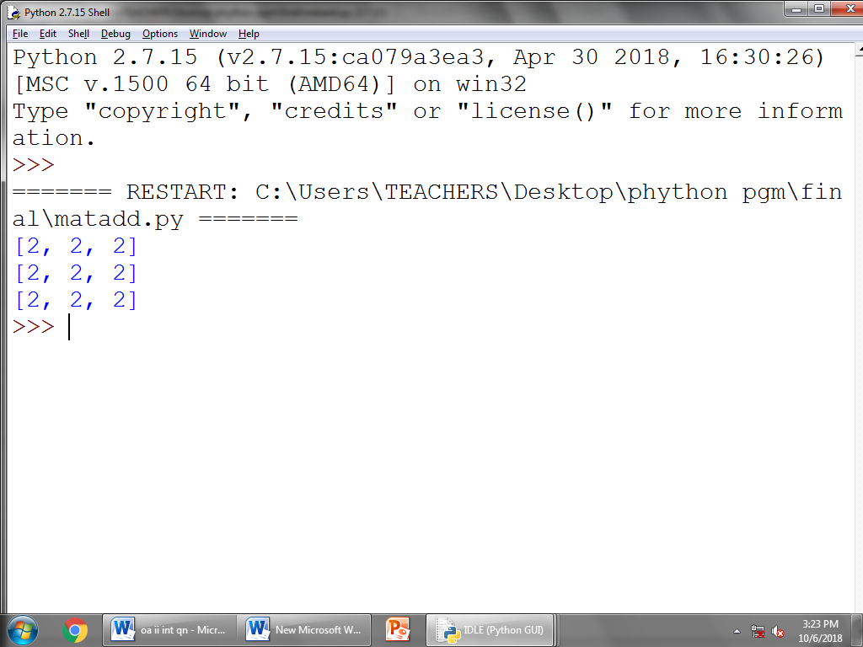

**RESULT:**

Thus the program was successfully executed and output is verified.

**EX NO:07 MATRIX MULTIPLICATION**

**DATE:**

**AIM:**

To write a python program was matrix multiplication for two numbers.

**ALGORITHM:**

1. Open Python IDLE
2. Click File -> New file
3. Type the program
4. Save the program with .py extension
5. To execute the program click Run or press F5
6. Exit

**PROGRAM:**

x=[[1,1,1],[1,1,1],[1,1,1]]

y=[[1,1,1],[1,1,1],[1,1,1]]

result=[[0,0,0],[0,0,0],[0,0,0]]

for i in range(len(x[0])):

for j in range(len(y[0])):

for k in range(len(y[0])):

result[i][j]+=x[i][j]*y[k][j]

for r in result:

print(r)

**OUTPUT:**

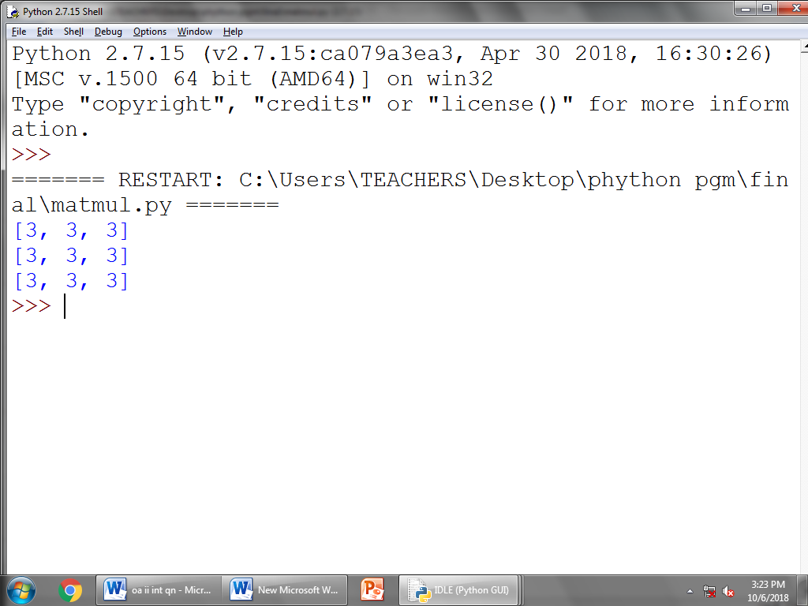

**RESULT:**

Thus the python program was successfully executed and output is verified.

**EX NO:08 SUM OF SERIES**

**DATE:**

**AIM:**

To calculate the sum of series given two numbers.

**ALGORITHM:**

1. Open Python IDLE
2. Click File -> New file
3. Type the program
4. Save the program with .py extension
5. To execute the program click Run or press F5
6. Exit

**PROGRAM:**

n=int(input("Enter the number of terms:"))

x=int(input("Enter the value of x:"))

sum1=1

for i in range(2,n+1):

sum1=sum1+((x**i)/i)

print("The sum of series is",round(sum1,2))

**OUTPUT:**

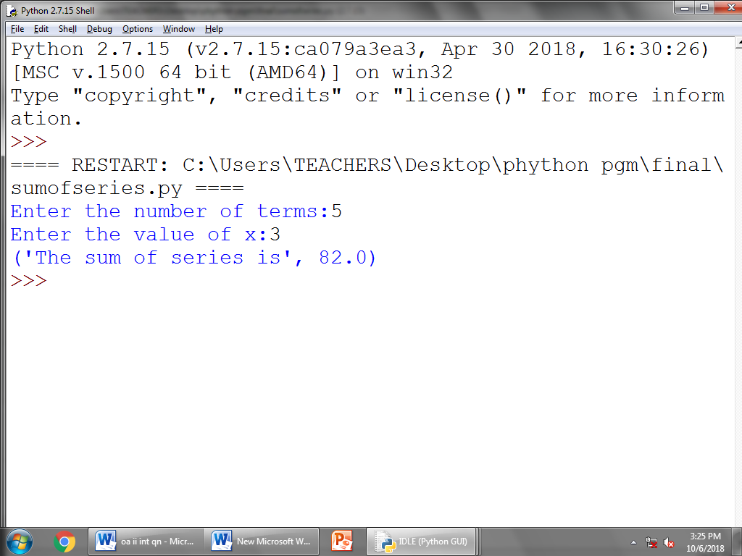

**RESULT:**

Thus the python program was successfully executed and output is verified.

**EX NO:09 PRIME NUMBER**

**DATE:**

**AIM:**

To write a python program was prime number calculation.

**ALGORITHM:**

1. Open Python IDLE
2. Click File -> New file
3. Type the program
4. Save the program with .py extension
5. To execute the program click Run or press F5
6. Exit

**PROGRAM:**

r=int(input("Enter the number: "))

k=0

for i in range(2,r//2+1):

if(r%i==0):

k=k+1

if(k<=0):

print(r,"is prime number")

else:

print(r,"is not prime number")

**OUTPUT:**

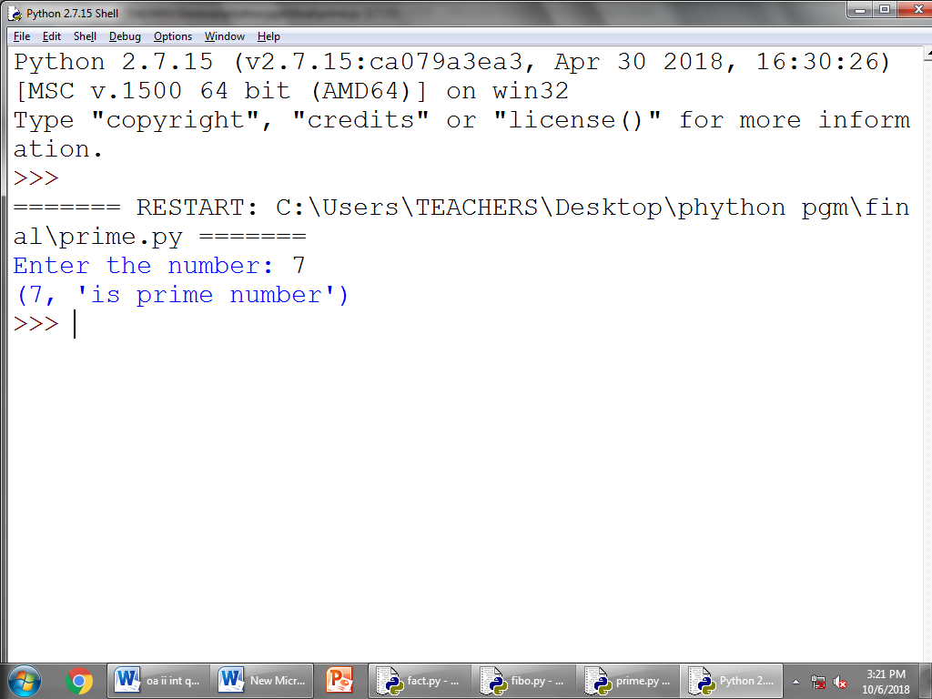

**NOT PRIME NUMBER**

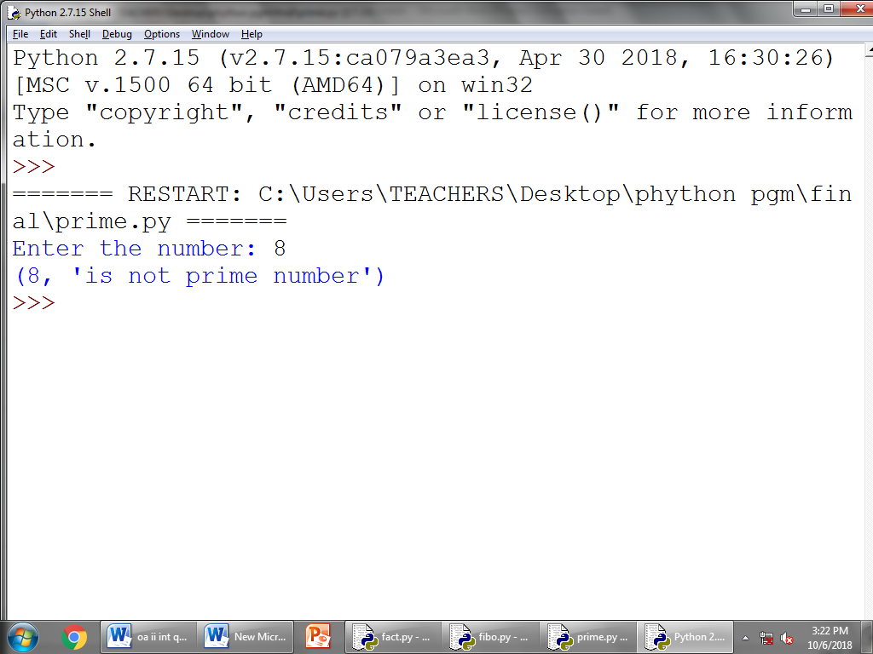

**RESULT:**

Thus the python program was successfully executed and output is verified.

**EX NO:10 AREA SHAPE CALCULATION**

**DATE:**

**AIM:**

To write a python program was area shape calculation.

**ALGORITHM:**

1. Open Python IDLE
2. Click File -> New file
3. Type the program
4. Save the program with .py extension
5. To execute the program click Run or press F5
6. Exit

**PROGRAM:**

def square(l):

area=l*l

return area

def rectangle(l,w):

area=l*w

return area

def triangle(b,h):

area=0.5*b*h

return area

def circle(r):

area=3.14*r*r

return area

print("Enter the number to calculate the area of shape")

print("1 = SQUARE")

print("2 = RECTANGE")

print("3 = TRIANGLE")

print("4 = CIRCLE")

ui=0

whileui not in (1,2,3,4):

ui=int(input("Enter your choice : "))

if (ui==1):

print("AREA OF SQUARE")

length=int(input("Length : "))

area=square(length)

print("Area of Square is : ",area)

if (ui==2):

print("AREA OF rectangle")

length=int(input("Length : "))

width=int(input("Width : "))

area=rectangle(length,width)

print("Area of Rectangle is : ",area)

if (ui==3):

print("AREA OF TRIANGLE")

base=int(input("Base : "))

height=int(input("Height : "))

area=triangle(base,height)

print("Area of Triangle is : ",area)

if (ui==4):

print("AREA OF CIRCLE")

radius=int(input("Radius : "))

area=circle(radius)

print("Area of Circle is : ",area)

**OUTPUT:**

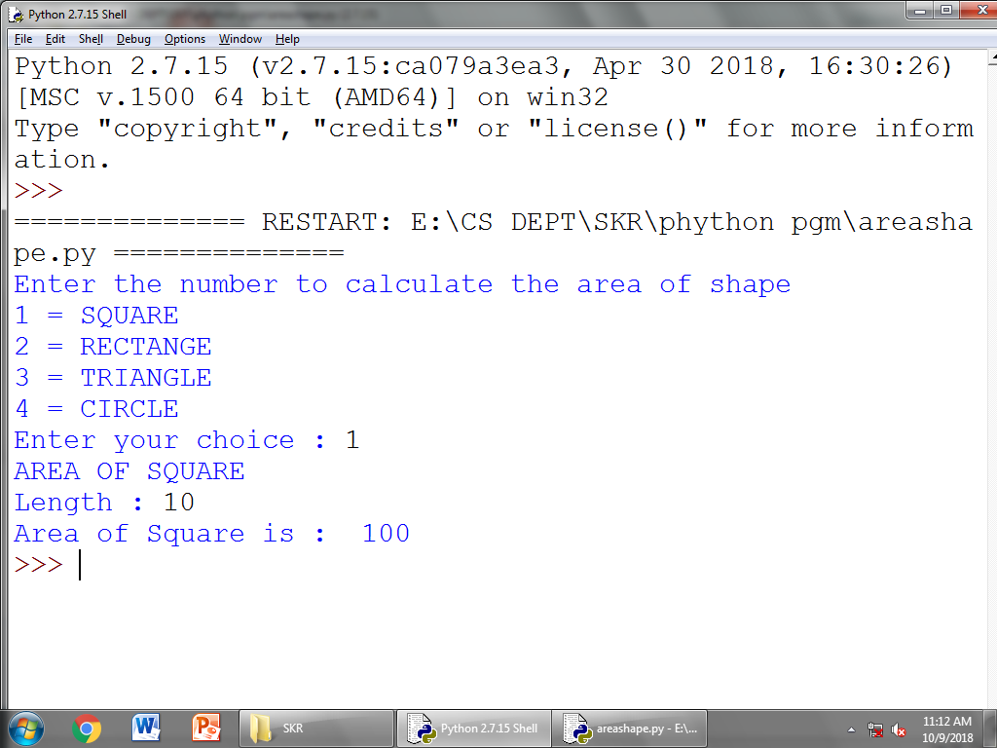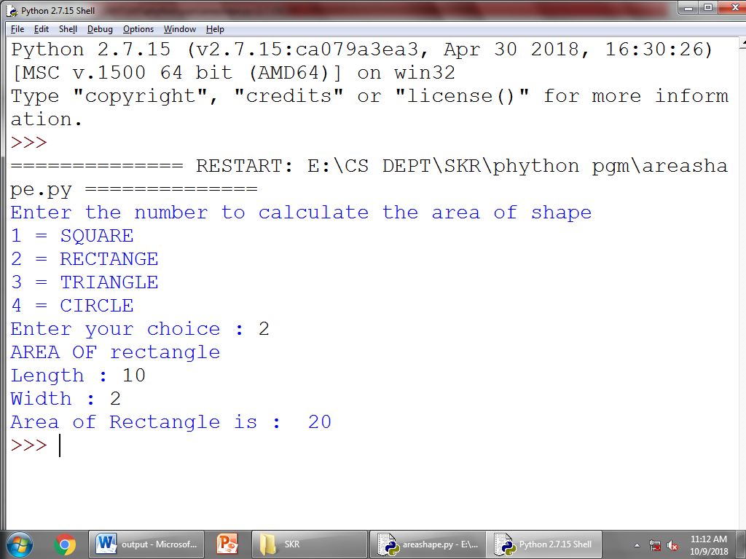

**RESULT:**

Thus the program was successfully executed and output is verified.

**EX NO:11 TO DRAW THE SHAPE AND OBJECT**

**DATE:**

**AIM:**

To write a python program was to draw the shape and object.

**ALGORITHM:**

1. Open Python IDLE
2. Click File -> New file
3. Type the program
4. Save the program with .py extension
5. To execute the program click Run or press F5
6. Exit

**PROGRAM:**

import turtle

print("Enter the number to draw the shape")

print("1 = STAR")

print("2 = SQUARE")

print("3 = TRIANGLE")

print("4 = HEXAGAN")

ui=0

whileui not in (1,2,3,4):

ui=int(input("Enter your choice : "))

if (ui==1):

wn=turtle.Screen()

wn.bgcolor("light green")

skk=turtle.Turtle()

skk.color("blue")

wn.title("STAR")

for i in range(5):

skk.forward(50)

skk.right(144)

turtle.done()

if (ui==2):

wn=turtle.Screen()

wn.bgcolor("light green")

skk=turtle.Turtle()

skk.color("blue")

wn.title("SQUARE")

for i in range(4):

skk.forward(50)

skk.right(90)

turtle.done()

if (ui==3):

wn=turtle.Screen()

wn.bgcolor("light green")

skk=turtle.Turtle()

skk.color("blue")

wn.title("TRIANGLE")

for i in range(3):

skk.forward(150)

skk.left(120)

turtle.done()

if (ui==4):

wn=turtle.Screen()

wn.bgcolor("light green")

skk=turtle.Turtle()

skk.color("blue")

wn.title("HEXAGON")

for i in range(6):

skk.forward(70)

skk.right(360.0/6)

turtle.done()

**OUTPUT:**

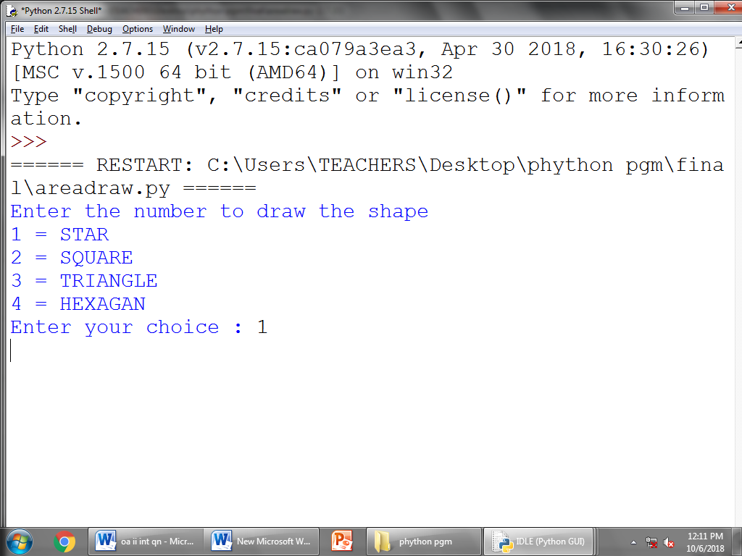

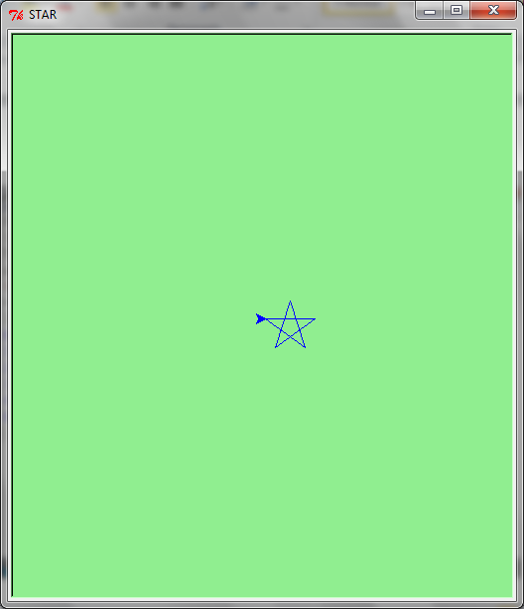

**RESULT:**

Thus the python program was successfully executed and output is verified.

**EX NO:12 HISTOGRAM**

**DATE:**

**AIM:**

To write a python program was histogram for graph.

**ALGORITHM:**

1. Open Python IDLE
2. Click File -> New file
3. Type the program
4. Save the program with .py extension
5. To execute the program click Run or press F5
6. Exit

**PROGRAM:**

importnumpy as np

importmatplotlib.pyplot as plt

data = [5,10,20,30,40]

plt.hist([2,12,22,32,42,52], bins=[0,5,10,15, 20,30,40,50,60],

weights=[10,25,40,33,6,8], edgecolor="yellow")

plt.show()

**OUTPUT:**

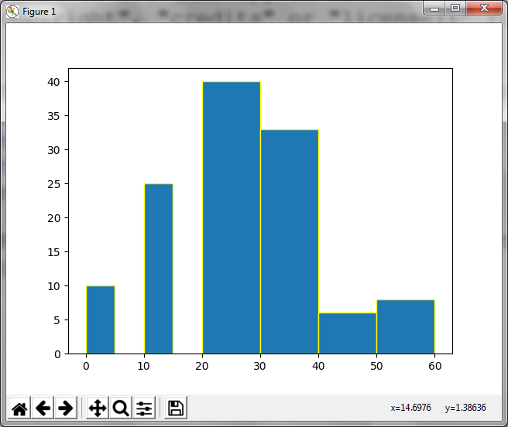

**RESULT:**

Thus the python program was successfully executed and output is verified.

**EX NO:13 SINE, COS AND EXPONENTIAL**

**DATE:**

**AIM:**

To write a python program was sine cosh and exponential graph.

**ALGORITHM:**

1. Open Python IDLE
2. Click File -> New file
3. Type the program
4. Save the program with .py extension
5. To execute the program click Run or press F5
6. Exit

**PROGRAM:**

fromnumpy import *

frommatplotlib.pyplot import *

x = linspace(0, 2*pi, 101)

y = ( np.exp(-x))

C, S = np.cos(x), np.sin(x)

plot(x, C, color = "blue", linewidth = 1,

linestyle = "-", label = r'$y = cos(x)$')

plot(x, S, color = "red", linewidth = 1,

linestyle = "-", label = r'$y = sin(x)$')

plot(x, y, color = "cyan", linewidth = 1,

linestyle = "-", label = r'$y = exp(-x)$')

legend(loc = 'upper right')

show()

**OUTPUT:**

**­­**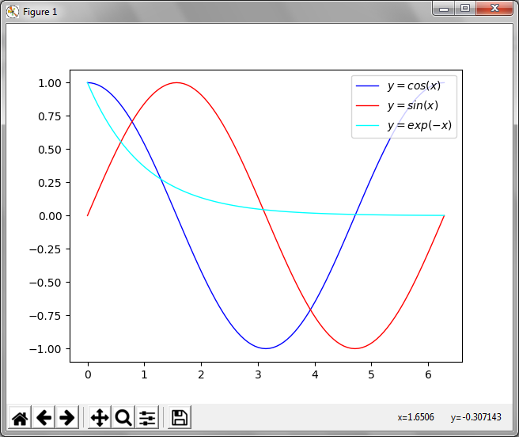

**RESULT:**

Thus the program was successfully executed and output is verified.

**EX NO:14 EXPONENTIAL**

**DATE:**

**AIM:**

To write a python program was exponential for graph.

**ALGORITHM:**

1. Open Python IDLE
2. Click File -> New file
3. Type the program
4. Save the program with .py extension
5. To execute the program click Run or press F5
6. Exit

**PROGRAM:**

import numpy as np

import matplotlib.pyplot as plt

a = 5

b = 2

c = 1

x = np.linspace(0, 10, 256, endpoint = True)

y = (a * np.exp(-b*x)) + c

plt.plot(x, y, '-r', label=r'$y = 5e^{-2x} + 1$')

axes = plt.gca()

axes.set_xlim([x.min(), x.max()])

axes.set_ylim([y.min(), y.max()])

plt.xlabel('x')

plt.ylabel('y')

plt.title('Exponential Curve')

plt.legend(loc='upper left')

plt.show()

**OUTPUT:**

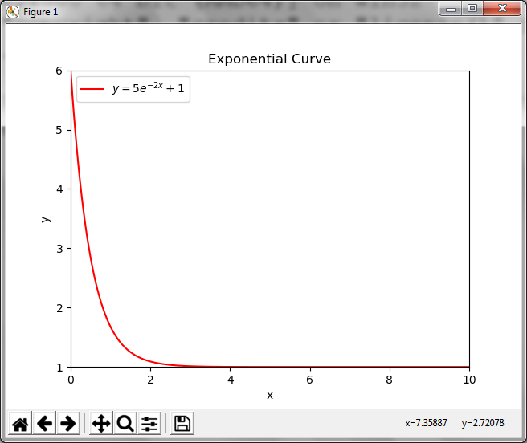

**RESULT:**

Thus the python program was successfully executed and output is verify.

**EX.NO:15 INHERITANCE**

**DATE**: _______________________________________________________________________________________

**AIM:**

To Write a Python Program for Demo.

**Algorithm:**

1. Open Python IDLE
2. Click File -> New file
3. Type the program
4. Save the program with .py extension
5. To execute the program click Run or press F5
6. Exit.

**program:**

class A:

def feature1(self):

print("Feature 1 working")

def feature2(self):

print("Feature 2 working")

class B:

def feature3(self):

print("Feature 3 working")

def feature4(self):

print("Feature 4 working")

class C(A,B):

def feature5(self):

print("Feature 5 working")

a1 = A()

a1.feature1()

a1.feature2()

b1 = B()

c1 = C()

**output:**

Feature 1 working

Feature 2 working

**Result:**

Thus the python program was successfully executed and output is verify.

**EX.NO:16 CONSTRUCTORS IN INHERITANCE**

**DATE:**

___________________________________________________________________________

**AIM:**

To Write a Python Program for Constructors In Inheritance.

**Algorithm:**

1. Open Python IDLE
2. Click File -> New file
3. Type the program
4. Save the program with .py extension
5. To execute the program click Run or press F5
6. Exit

**program**:

class A:

def __init__(self):

print("in A Init")

def feature1(self):

print("Feature 1-A working")

def feature2(self):

print("Feature 2 working")

class B:

def __init__(self):

# super().__init__()

print("in B Init")

def feature3(self):

print("Feature 1-B working")

def feature4(self):

print("Feature 4 working")

class C(A,B):

def __init__(self):

super().__init__()

print("in C init")

def feat(self):

super().feature2()

a1 = C()

a1.feat()

**output:**

in A Init

in C init

Feature 2 working

**Result:**

Thus the python program was successfully executed and output is verify.

**EX.NO:17 MULTI THREADING**

**DATE**:

_________________________________________________________________________

**AIM:**

To Write a Python Program for Multithreading Program.

**Algorithm:**

1. Open Python IDLE
2. Click File -> New file
3. Type the program
4. Save the program with .py extension
5. To execute the program click Run or press F5
6. Exit

**program:**

from time import sleep

from threading import *

class Hello(Thread):

def run(self):

for i in range(5):

print("Hello")

sleep(1)

class Hi(Thread):

def run(self):

for i in range(5):

print("Hi")

sleep(1)

t1 = Hello()

t2 = Hi()

t1.start()

sleep(0.2)

t2.start()

t1.join()

t2.join()

print("Bye")

**output:**

Hello

Hi

Hello

Hi

Hello

Hi

Hello

Hi

Hello

Hi

Bye

**Result**:

Thus the python program was successfully executed and output is verify.

**EX.NO:18 SELECTION SORTING**

**DATE:**

**________________________________________________________________________**___

**AIM:**

To Write a Python Program for selection sort Program.

**Algorithm:**

1. Open Python IDLE
2. Click File -> New file
3. Type the program
4. Save the program with .py extension
5. To execute the program click Run or press F5
6. Exit

**program:**

def sort(nums):

for i in range(5):

minpos = i

for j in range(i,6):

if nums[j] < nums[minpos]:

minpos = j

temp = nums[i] nums[i] = nums[minpos]

nums[minpos] = temp

print(nums)

nums = [5, 3, 8, 6, 7, 2]

sort(nums)

print(nums)

**output:**

[2, 3, 8, 6, 7, 5]

[2, 3, 8, 6, 7, 5]

[2, 3, 5, 6, 7, 8]

[2, 3, 5, 6, 7, 8]

[2, 3, 5, 6, 7, 8]

[2, 3, 5, 6, 7, 8]

**Result:**

Thus the python program was successfully executed and output is verify.